Name _____________________________

Directions: Color each number a color (using different colors for each)
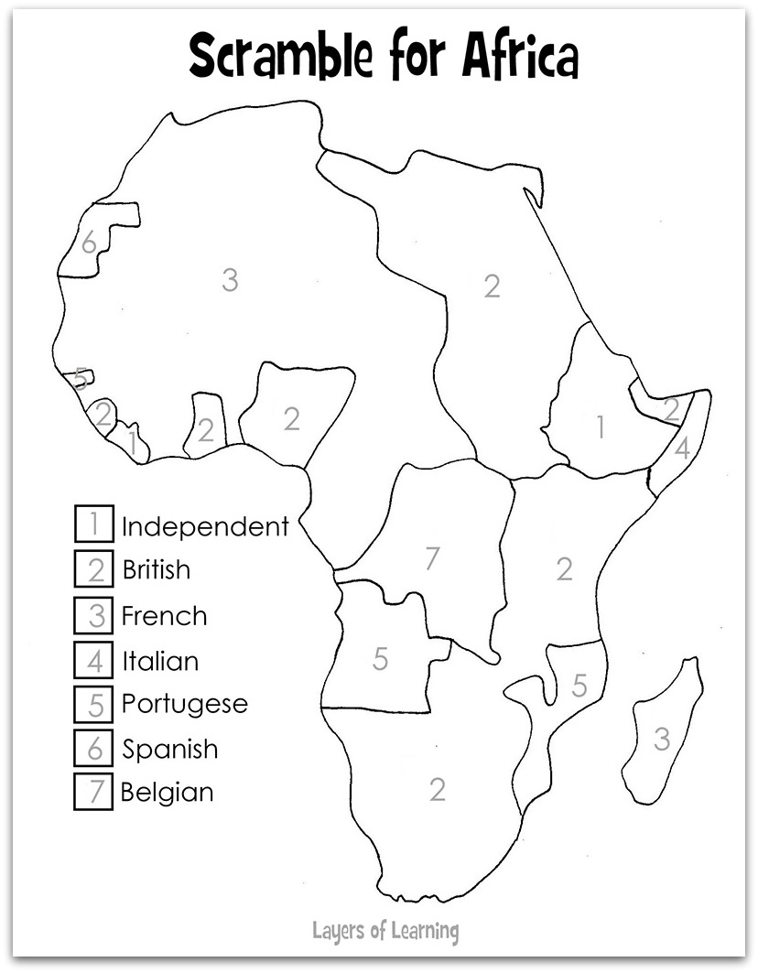

Social Studies Theme:
Conflict / Change

Directions: Using your notes, fill in the missing information.

SS6H6 Explain the impact of European empire building in Africa and Asia on the outbreak of World War I.

Essential Question:
How did the existence of large European colonial empires in Africa and Asia impact the outbreak of World War I?

- Nearly all areas of ______________________were controlled by European powers in 1914.
- Large portions of _____________________were also controlled by European powers directly or by influencing local leaders
- _________________________- European nations were constantly looking for more land to colonize.
- These colonies supplied Europe with______________________, ___________________________, and added to their sense of ______________or greatness.
- Since ______________________controlled Africa and most of Asia, few areas were left to colonize.
- This created ____________________between the old superpower countries of Great Britain and France and the newer rising powers of Germany, Russia, and Italy.
- ______________________________ is a feeling of intense loyalty to one’s country.
- ______________________caused by nationalism led to WWI.
- ________________________________caused new nations to be formed such as Germany and Italy.
- These nations challenged the _____________________________of older European nations.
- Nationalism also threatened to break apart___________________, such as Austria – Hungary, because different _____________________________wanted independent nations of their own
- ___________________________/___________________________Nations began building up their armies to protect their very profitable colonies.
- As the militaries grew bigger, all of the countries began to feel _________________by each others’ huge armies.
- This created _______________________among Europe and bitter rivalries developed between the countries
- ________________________________: As tensions grew, countries began forming alliances, or defense agreements, to help each other out if a war started.
- Many thought that this would help _______________________war, but it actually contributed to a HUGE war.
- Their_____________________, or friends, would have to get into the war as well.
- By 1914, Europe had divided into two powerful______________________________:

TRIPLE ALLIANCE  *  *  * | TRIPLE ENTENTE  *  *  *
Political Cartoons
Answer the following: What does the cartoon tells us about imperialism? Does the cartoon portray imperialism in positive or negative terms? Refer to details in the cartoon in your answer.



